NZ Diploma in Cybersecurity

Course No: HTCS6707 | Cybersecurity Project | Level: 6  Credits: 30

Student Name: | Student ID:
Assessment Type: Portfolio Deliverable (Cybersecurity Project) | Weighting: 25%
Due Date: See Course Schedule | Total Marks: 160

Student declaration
I confirm that:
• This is an original assessment and is entirely my own work.
• The work I am submitting for this assessment is free of plagiarism. I have read and
understood the Academic Integrity Policy here. I have also read and understood the
Student Disciplinary Statue here.
- Where I have used ideas, tables, diagrams etc of other writers, I have acknowledged the source in every case.

Students Signature: | Date:

Assessment Mapping

After completing this assessment, the student will have met the following learning outcomes related to the graduate profile outcome.

Graduate Profile Outcome | Learning Outcome | Tasks
Apply knowledge of risk management frameworks to perform cybersecurity risk assessments and communicate the results to support the organisational risk management process | Apply cybersecurity risk assessment to develop a project plan to produce cybersecurity solution | 1, 2
Assess, select, plan, implement and validate cybersecurity approaches and controls to support organisational objectives and operations | Assess and select cyber technologies to implement and validate cybersecurity solution to meet business requirements | 1, 2
Apply communication, information design, teamwork, personal, and interpersonal skills, to enhance working effectiveness, efficiency, and quality outcomes in a variety of situations in an organisational environment. | Apply communication skills to collaborate and present project development life cycle to relevant stakeholders | 1, 2, 3, 4
Apply project management tools and techniques, using knowledge of project planning, management and control, to an IT related project, to analyse and solve problems | Apply critical thinking skills to produce innovative and timely solution for a cybersecurity project  Apply project management tools and techniques to manage the project efficiently. | 1, 2

Assessment instructions:
- This is a group assessment of 3 members.
- Read the scenario carefully.
- The group needs to provide a working network equipped with security and detection mechanisms.
- The group needs to demonstrate that the protection mechanisms can detect security breaches.
- The group needs to provide a report of 3000 words +/- 10% to describe the technical configurations of key elements of the network and the security mechanisms.
- The group must make sure that everything is ready for demonstration before the due date.
- Table 1.1 lists the marks of the detailed tasks.
Scenario

Analyse the network scenario in the diagram below. The network should satisfy the requirements listed below.

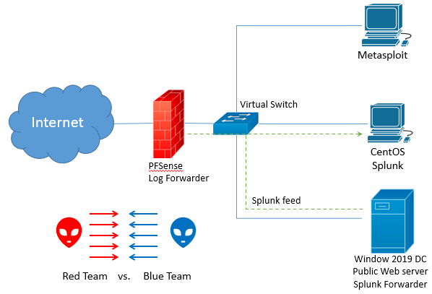

Network Requirements

- The internal network is isolated from the public domain by a PFSense Firewall.
- The Window server 2019 is a Domain Controller (DC), a DHCP server to distribute IP addresses internally, a DNS server, and a public Web server.
- Splunk is installed on CentOS and is fed by logs from the server (which acts as Splunk Forwarder) and the firewall. The CentOS is a DHCP client
- Metasploitable is a DHCP client.
- The Blue Team is responsible of protecting the network without affecting the business operations.
- The Red Team is responsible of testing the network with different tools. Tools can be used from Kali Linux or tests from “Atomic Red Team” (https://atomicredteam.io/)

Planning:

The project will have the following main phases during its lifetime (week 2 – week 12):
- Build the network
- Secure the Network
- Test the network with Red and Blue Team
- Demonstrate the work (Week 12)

Your Tasks:

- Produce a WBS (work breakdown structure) plan for your project. The WBS should show the detailed tasks for each phase distributed equally among the group members and logically over the lifetime of the project. Your WBS plan will be used to follow your implementation later.
- Implement each phase as described in your WBS
- Investigate to answer the following questions:
  - What is Cybersecurity Operation Centre (SOC)?
  - What tools are essential for SOC to operation well?
  - What skills you need to have to be a security Analyst?
- Produce a report of 3000 words +/- 10% to describe the technical configurations of the key elements of the network and the security mechanisms. The report includes 1000 words to answer Task 3. You should not exceed the words limit of the report. However, you can use as many appendices as you want (appendices are not included in the words count).
- Demonstrate your implementation of the above phases in Week 12.

Hardware requirements

- You need to implement the network in a virtual environment.

List of Resources

- Atomic Red Team: https://atomicredteam.io/
- SecurityOnion (https://securityonionsolutions.com/) – Optional reading
- Splunk Enterprise 8.2.x:
https://www.splunk.com/en_us/download/splunk-enterprise.html#tabs/linux
- Splunk Universal Forwarder 8.2.1 Remote Data Collection:
https://www.splunk.com/en_us/download/universal-forwarder.html

Duty list

In case tasks were not distributed equally by the end of the project, the group needs to submit a duty list (according to the below template) to clarify the tasks carried out by each member and their overall contribution to the project.
Group Member | List of duties | Overall contribution in the project
Missing tasks because of lack of contribution of some members

Marking Sheet

Group Members:

Table 1.1 – Marks Distribution
Tasks | Allocated mark | Mark given | Comments
WBS  - Show the detailed tasks to cover each main phase 14  - Tasks are distributed equally among the group members 3  - Tasks are distributed logically over the lifetime of the project 3 | 20
Demonstration
Building the network  All the functioning requirements of the network have been satisfied:  - Domain controller is installed and properly configured 3  - DHCP server distrusted IP addresses internally 4  - Web server call be accessed properly 3  - CentOS installed and part of the network 3  - Metasploitable VM is installed and part of the network 3  - Firewall internal interface has a static IP address 2  - Firewall external interface is configured properly 2 | 20
Securing the Network  - Firewall is behaving as expected with proper rules 6  - Splunk is installed properly on CentOS 5  - Splunk Forwarder is installed on the server and configured properly with Splunk Server 8  - Firewall sends its log properly to Splunk Server 6 | 25
Test the network with Red and Blue Team  - Demonstrate 3 different tools used by the red team to test the network (3x5)  - Demonstrate Splunk can capture the feed from the server, the firewall or any attack 5 | 20
Report  - Description about the SOC 5  - Description of at least 3 essential tools inside the SOC and its functionalities (3x5)  - Description of the skills of Security analyst 5  - General network diagram 5  - Network diagram is explained properly 5  - Main tasks are described with technical details if necessary 20  - The writing is clear, flow logically and with no mistakes 5  - Figures / Tables are clear with proper description and numbers 4  - Any external work should be cited properly and references are provided by the end of the report 5  - References should follow the IEEE or APA-7 format 3  - The report is properly formatted 3 | 75
TOTAL | 160

